

Build
Installation Guide

Prepared by: Rapid Solutions and Consulting LLC
Last Updated: December 20, 2016

Table of Contents
1. Introduction 3
2. Prerequisites 4
3. Installation 8
4. Appendix A: Troubleshooting 9
5. Further Reading 16

1. Introduction

RapidBuild (Build) is a tool part of the Rapid client suite used to automate the setup of Oracle Applications configurations using the Oracle Forms playback and HTML technology to inject configurations. It is a desktop application written in JAVA which will commnicate with your EBS oracle instance.

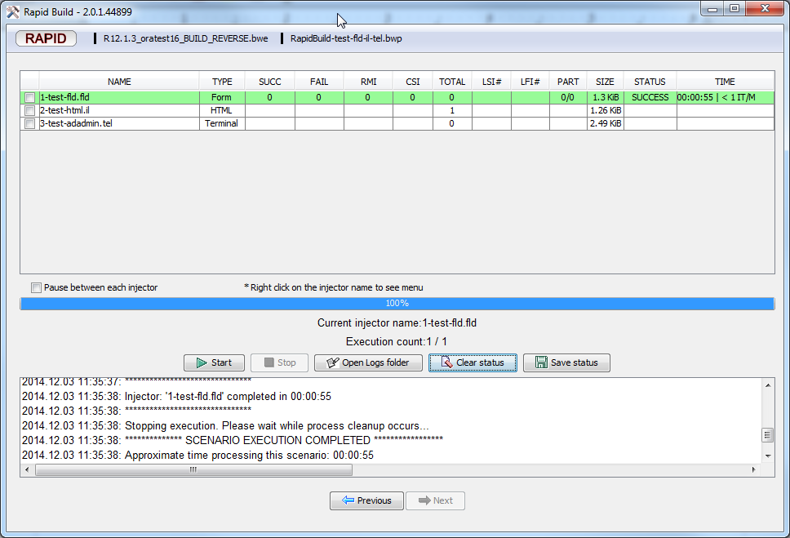

2. Prerequisites

RapidBuild is certified only when configured under the following requirements.

2.1 EBS configuration requirements

    - Oracle Forms Playback
Oracle Forms Playback must be enabled before Build can work with the EBS, please see the instructions on how to enable Oracle Forms Playback:

http://docs.rapidesuite.com/Home/manuals/formsplayback

    - SFTP or FTP or SSH user
As part of its injection operation, Build requires the SFTP or FTP or SSH user for the ability to both upload and download FLD scripts to the Oracle EBS server for Oracle Forms playback technology.
Usually, the user can be simply Oracle applications tier owner or “applmgr” by Oracle default installation or another user that has enough permission to upload the download file on the folder set by EBS context variable below:
R12: forms_trace_dir
R11: forms_trace_path
Fore more information about context variables, please read the Oracle Forms Playback document above.
If the simple Oracle applications tier owner user above cannot be provided and additional information are need to setup the account, please contact us for more information.

2.2 Software requirements
The following software must be installed and configured properly as per the instructions in order for Build to work as expected.

- Internet Explorer is intended to be used when injecting Oracle Forms.
- Mozilla Firefox 16.0.2 is intended to be used for injecting Oracle HTML pages.
  - https://ftp.mozilla.org/pub/firefox/releases/16.0.2/win32/en-US/ (Windows)
  - https://ftp.mozilla.org/pub/firefox/releases/16.0.2/linux-i686/en-US/ (Linux)
- Oracle Jinitiator or Java Runtime Environment Browser add-ons must be installed.

R12 EBS prerequisites:

- Internet Explorer.

- For the Windows XP operating system, one of the following:
Internet Explorer 6.
Internet Explorer 8.
- For Windows Vista and Windows 7 operating systems, one of the following:
Internet Explorer 8.
Internet Explorer 9.

- Mozilla Firefox.
- Windows XP, Windows Vista and Windows 7 operating systems.
Firefox 16.0.2.
- Oracle Java Runtime Environment:
32-bit operating system
    - 32-bit JRE 1.6.0_32 or higher as Oracle certified with your EBS version.
64-bit operating system
    - 32-bit JRE version 1.6.0_32 or higher as Oracle certified with your EBS version. (Recommended).
If there is only 32-bit JRE can be installed then changing Build parameter below is required.
Edit the engine.properties file which is located under the folder Build is installed to ensure the “BUILD_FLD_BROWSER_LAUNCHER_COMMAND_WINDOWS_64” parameter is set to Internet Explorer 32-bit such as below:
BUILD_FLD_BROWSER_LAUNCHER_COMMAND_WINDOWS_64=C:/PROGRA~2/INTERN~1
    - 64-bit JRE version 1.6.0_32 as Oracle certified with your EBS version (Optional).
The benefit is the injecting Oracle Forms and Forms Playback technology by 64-bit browser with 64-bit JRE is a bit faster. See “Identifying version of Internet Explorer 32 bit or 64 bit that being used for injection” under “9. Appendix A: Troubleshooting” topic to help you set the this environment” topic.

R12 Notes:

Forms crash
Build under Windows XP and Multiple (Dual) core CPU environment may cause the Forms to hang, please see more information on “Oracle bug multi-processor/multi-core” subject under “9. Appendix A: Troubleshooting” topic.

R11 prerequisites

- Window XP 32 bit operating system.
- Internet Explorer 6.
- Firefox 2.0.0.20.
- Oracle Jinitiator or Java Runtime Environment corresponding to the EBS R11 server.
When using RapidBuild, customers should use this environment only. No other environments have been certified for use with RapidBuild.
Note: Rapid E-Suite Build is not certified for injecting an EBS R11 installation from a Windows 7 client, and such an environment is explicitly not supported.
R11 Notes
Forms crash
From Oracle Document ID:601534.1 notice that SUN JRE will crashes or hangs with the browser that having Hyper-threading Enable on some versions of JInitiator.. You can find solution in Oracle Document ID:601534.1 and more information in “9. Appendix A: Troubleshooting” topic.

Support will be given for customers using alternate environments on a lower-priority basis. If Rapid Solutions technical support determines that the customer issue in question is affected by deviation from the certified application environment, the customer will be advised to change said environment. Subsequent support requests from the customer will be closed if the customer continues to use a non-certified environment.

  - Hardware requirements

2.3.1 Minimum:
    - Single core processor 2.4 GHz or equivalent.
    - 1 GB of memory (RAM) if running Windows Vista/ Windows 7.
    - 512 MB of memory (RAM) if running Windows XP.

2.3.2 Recommended:
    - 3 GB of memory (RAM) if running Windows Vista/ Windows 7.
    - 2 GB of memory (RAM) if running Windows XP.

3. Installation
- Download the Installer file from our download site.
- Run the installer file (example: rapidclient-2.0.1.44014-installer.exe or latest) or the unpacked version (ZIP file)
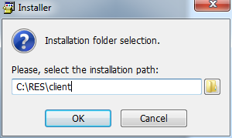

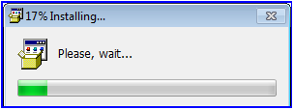

After completing the Installation, a Build shortcut Icon will appear on your Desktop.



4. Appendix A: Troubleshooting
This section describes the most common issues with Build and their resolutions.

- Build installation warning on Windows 7

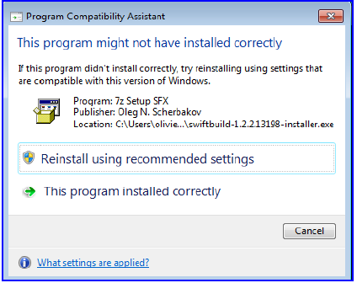
Just click “This program installed correctly”.

- Java Heap size

Sometimes Oracle Apps hangs while injecting, mainly because the JAVA heap size is too small. To increase the JAVA heap size, please do the following:

Control panel -> Java or Jinitiator (depending which is used by the browser, if in doubt, repeat for all of them) -> Java tab -> View -> in Runtime parameters, put -Xmx256M
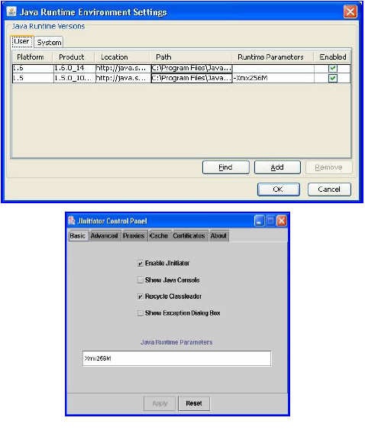

- Many Java icons showing in the Windows menu bar.

Hovering the mouse over them will force Windows to close them.
Also you can disable the checkbox in the Control panel-> Java; so that the icons never show up in the system tray. See below:
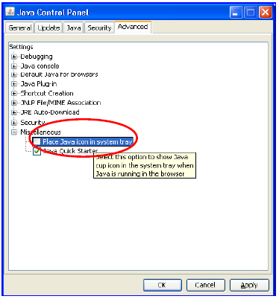

- Oracle Forms closing on Internet Explorer 8

The Oracle Apps applet just crashes and closes on IE8 when performing injections.
Uncheck the “Enable automatic crash recovery*” box in Internet Options.

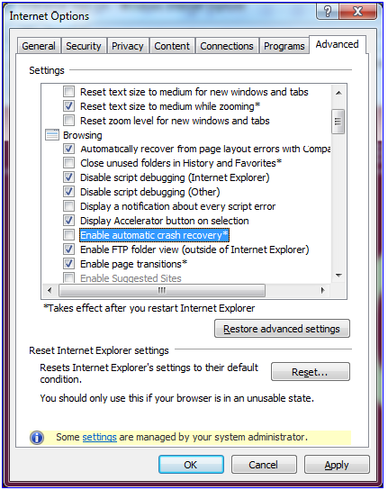

- Identifying the version of Internet Explorer 32 bit or 64 bit that being used for injection
        - Open engine.properties is located under the folder where you installed Build.
        - Find this line and copy path to iexplore.exe only, like picture below. The path might not the same path you see in the example.
BUILD_FLD_BROWSER_LAUNCHER_COMMAND_WINDOWS_32=C:/Program Files/Internet Explorer/iexplore.exe
        - Click “Start”. For Window XP you need to click “Run”. And then you can paste what you copy in 2. to “Run” box and then press “Enter”.
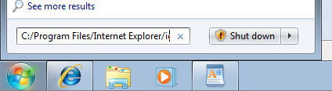
        - Window Internet Explorer will open.

4.1 For IE6 and IE8 in Window XP click “Help”.
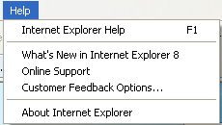

4.2 For IE8 in Window 7 click “?”.
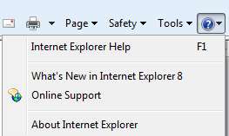
4.3 For IE9 click gear sign as the top right of the picture below.

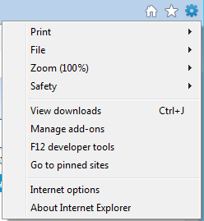
        - Click “About Internet Explorer”. Small window will appear. If the right of IE version line notice 64 bit then you use 64 bit Edition for injection. You can see an Example picture below compare 64 bit on the left and 32 bit on the right.

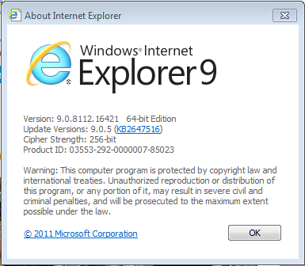
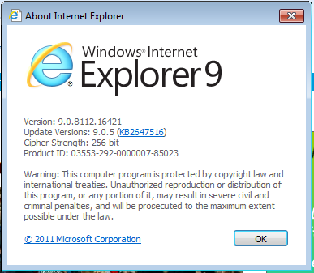
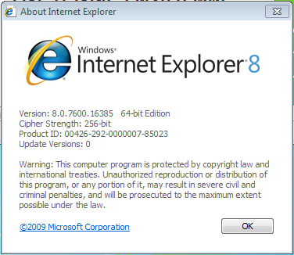

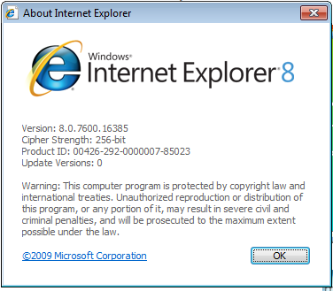

- Find your Oracle Java Runtime Environment in Window 7 and Window Vista

Click “Start” → “Control Panel”→ “Uninstall a program”, you will find installed Java.
For Window XP please click “Start” → “Control Panel”→ “Add or Remove Programs”.

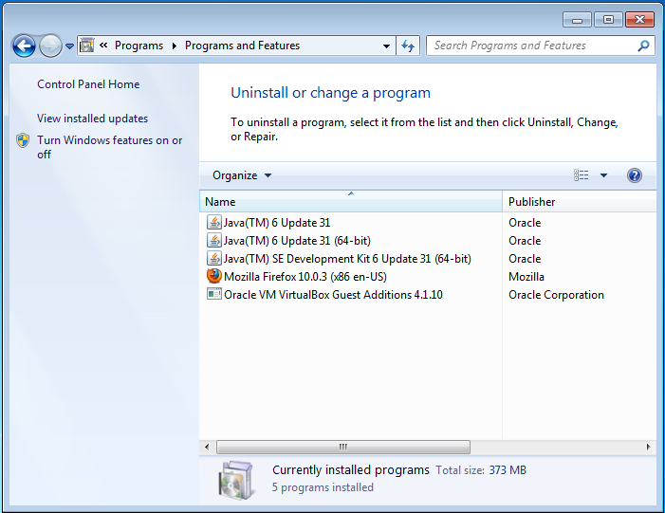

5. Further Reading

Please consult the RAPID Build User Guide for information on how to use RAPIDBuild.

